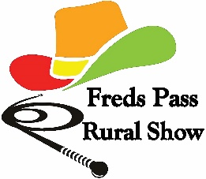 FREDS PASS RURAL SHOW
ENTRY FORM
One entry form per person/child
Section | Class | No of  Entries | Description of Class | Entry Fee
 |  |  | Total Amount

Entrant’s name:………………………………………………………………………………………………………………………………..……………
Entry placed by (if different from above eg parent):……………………………………….…………………………………..…………
Group/School/Class (if entry placed by teacher/leader):…………………………….………………………………..……………….
Postal Address:…………………………………………………………………………………………….………………………………………………..
…………………………………………………………………………………………………………….………………………………………………………..
Email:……………………………………………………………………………………...……..Phone:…………………………………………………
Age of child (if junior entry):……………………….
My involvement in the Freds Pass Rural Show is based on a hobby. YES
NO Business name:………………………………………………………………………….. ABN…………………………………………………
I declare these entries to be my bona fide work or are the bona fide work of the child under 18 years I am preparing this entry for. I agree to abide by the Freds Pass Rural Show’s SHOW REGULATIONS AND CONDITIONS OF ENTRY FOR EXHIBITORS.
Signature:……………………………………………………………………………………………
Hand delivery only to Show Office (check opening hours) or the Nelson, Goyder, Daly, Brennan, Spillett, Drysdale and Blain Electoral Offices, with cash or cheque payment, by 10 May 2024

